1. اسم المشروع:

محاكاة مصعد من ثلاث طوابق

1. أسماء المتدربين
2. أحمد علي عايد الجهني 438211979
3. عامر عطيوي الجهني439131506
4. اياد طالب محمد عساف134362270

راوبط صفحة موقعGitHub

1. اسم المشروع

محاكاة مصعد بثلاث طوابق

1. شرح مبسط لفكرة عمل المشروع بشكل شامل

وجود 6 سوتشات

3منها لاختيار الدور

3 منها لاستدعاء كل دور

1. شرح العناصر الإلكترونية الأساسية في المشروع مدعومة بالصور

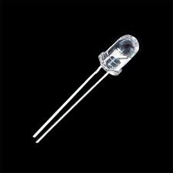

إضاءة led لتوضيح مكان الدور

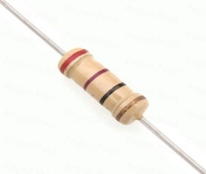

مقاومة لحماية العناصر الموجودة في الدائرة

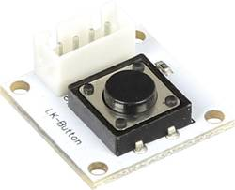

وجود سوتشات لاختيار الدور

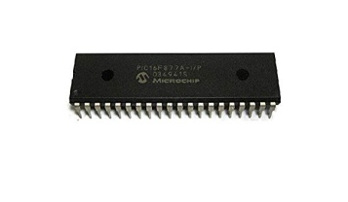

نوع البك PIC16F77A

1. شرح خطوات تنفيذ المشروع مدعومة بالصور

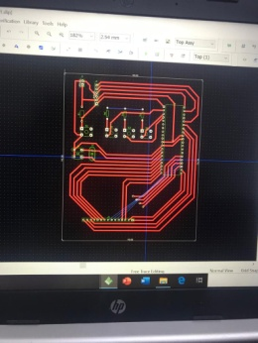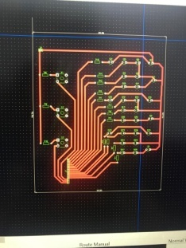

بناء الدائرة على برنامجDipTrace

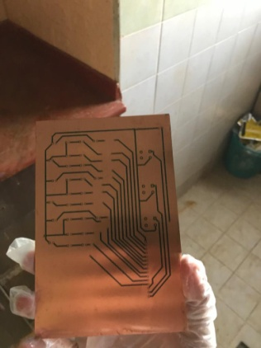

طباعة الدائرة الألكترونية على PCB

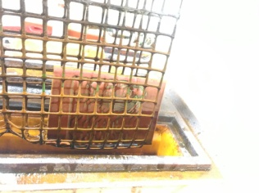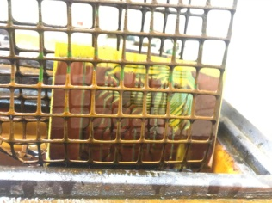

تحميض الدائرة

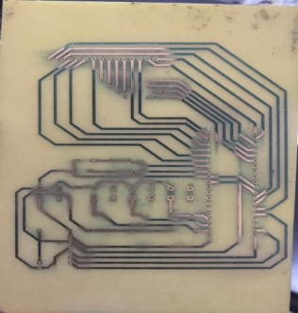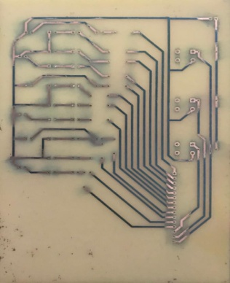

تنظيف وتخريم الدائرة المطبوعة

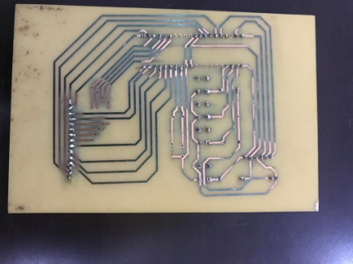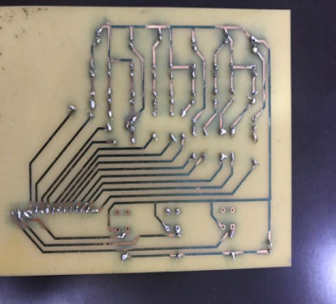

تلحيم الدائرة الالكترونية

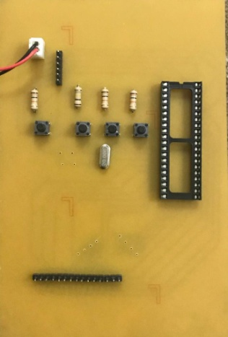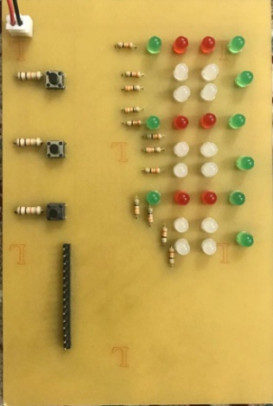

تلحيم العناصر الالكترونية الموجودة في الدائرة

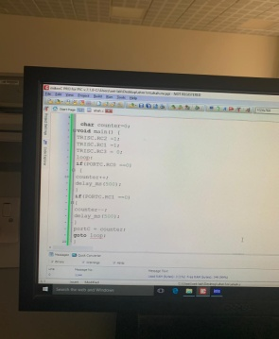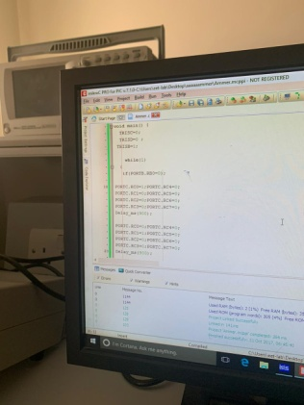

كتابة كود المشروع

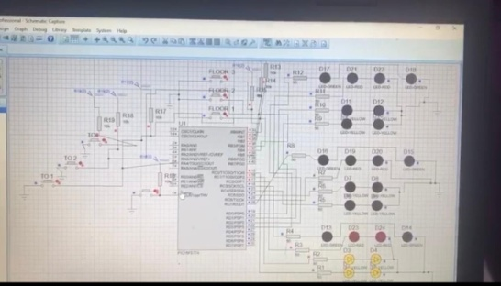

التاكد من صحة الكود البرمجي وتطبيق الدائرة على برنامجISIS

1. مقترحات تطويريه للمشروع

وجود شاشة LCD بحيث تبين مكان الدور بارقام ووجود جمله ترحيبيه بعد فتح الباب

1. تضمين المراجع في حال وجودها في الهامش
2. ارفاق الكود البرمجي

void main() {

trisC=0b00000000; PORTC=0;

TRISD=0b00000000;PORTD=0;

trise=0b00000000;

trisb=0b11111111;

trisa=0b11111111;

adcon1=0b00000110;

portc=0b00000111;

while (1)

{

//3333333333ddddd3333333333//

if(portB.RB0==0&& portc.rc0==1) //FROM 1 TO 3

{portC = 0b01000101;

portd =0b00000100;

delay_ms(1000);

portC = 0b01000110;

portd =0b00000100;

delay_ms(1000);

portC = 0b01010100;

portd =0b00000100;

delay_ms(1000);

portC = 0b01100100;

portd =0b00000100;

delay_ms(1000);

portC = 0b01000100;

portd =0b00000101;

delay_ms(1000);

portC = 0b01000100;

portd =0b00001011;

delay_ms(3000);

portC = 0b01000100;

portd =0b00000111;

}

else if(portB.RB0==0&& portc.rc4==1) //FROM 2 TO 3

{

portC = 0b01010100;

portd =0b00000100;

delay_ms(1000);

portC = 0b01100100;

portd =0b00000100;

delay_ms(1000);

portC = 0b01000100;

portd =0b00000101;

delay_ms(1000);

portC = 0b01000100;

portd =0b00000111;

delay_ms(1000);

portC = 0b01000100;

portd =0b00001011;

delay_ms(3000);

portC = 0b01000100;

portd =0b00000111;

}

else if(portB.RB0==0&& portd.rd0==1) //FROM 3 TO 3

{

portC = 0b01000100;

portd =0b00000111;

delay_ms(1000);

portC = 0b01000100;

portd =0b00001011;

delay_ms(3000);

portC = 0b01000100;

portd =0b00000111;

}

////22222222222ddddddd2222222222/////

if(portB.RB1==0&& portc.rc0==1) //FROM 1 TO 2

{portC = 0b01000101;

portd =0b00000100;

delay_ms(1000);

portC = 0b01000110;

portd =0b00000100;

delay_ms(1000);

portC = 0b01010100;

portd =0b00000100;

delay_ms(1000);

portC = 0b01110100;

portd =0b00000100;

delay_ms(1000);

portC = 0b10110100;

portd =0b00000100;

delay_ms(3000);

portC = 0b01110100;

portd =0b00000100;

}

else if(portB.RB1==0&& portc.rc4==1) //FROM 2 TO 2

{

portC = 0b01010100;

portd =0b00000100;

delay_ms(1000);

portC = 0b10110100;

portd =0b00000100;

delay_ms(3000);

portC = 0b01110100;

portd =0b00000100;

}

else if(portB.RB1==0&& portd.rd0==1) //FROM 3 TO 2

{

portC = 0b01000100;

portd =0b00000110;

delay_ms(1000);

portC = 0b01000100;

portd =0b00000101;

delay_ms(1000);

portC = 0b01100100;

portd =0b00000100;

delay_ms(1000);

portC = 0b10110100;

portd =0b00000100;

delay_ms(3000);

portC = 0b01110100;

portd =0b00000100;

}

///1111111111ddddddddd1111111111///

if(portB.RB2==0&& portd.rd0==1) //FROM 3 TO 1

{portC = 0b01000100;

portd =0b00000110;

delay_ms(1000);

portC = 0b01000100;

portd =0b00000101;

delay_ms(1000);

portC = 0b01100100;

portd =0b00000100;

delay_ms(1000);

portC = 0b01010100;

portd =0b00000100;

delay_ms(1000);

portC = 0b01000110;

portd =0b00000100;

delay_ms(1000);

portC = 0b01001011;

portd =0b00000100;

delay_ms(3000);

portC = 0b01000111;

portd =0b00000100;

}

else if(portB.RB2==0&& portc.rc4==1) //FROM 2 TO 1

{

portC = 0b01100100;

portd =0b00000100;

delay_ms(1000);

portC = 0b01010100;

portd =0b00000100;

delay_ms(1000);

portC = 0b01000110;

portd =0b00000100;

delay_ms(1000);

portC = 0b01001011;

portd =0b00000100;

delay_ms(3000);

portC = 0b01000111;

portd =0b00000100;

}

else if(portB.RB2==0&& portc.rc0==1) //FROM 1 TO 1

{

portC = 0b01000101;

portd =0b00000100;

delay_ms(1000);

portC = 0b01000110;

portd =0b00000100;

delay_ms(1000);

portC = 0b01001011;

portd =0b00000100;

delay_ms(3000);

portC = 0b01000111;

portd =0b00000100;

}

///TO 3333333333333//

if(portA.RA0==0&& portc.rc0==1) //FROM 1 TO 3

{portC = 0b01000101;

portd =0b00000100;

delay_ms(1000);

portC = 0b01000110;

portd =0b00000100;

delay_ms(1000);

portC = 0b01010100;

portd =0b00000100;

delay_ms(1000);

portC = 0b01100100;

portd =0b00000100;

delay_ms(1000);

portC = 0b01000100;

portd =0b00000101;

delay_ms(1000);

portC = 0b01000100;

portd =0b00001011;

delay_ms(3000);

portC = 0b01000100;

portd =0b00000111;

}

else if(portA.RA0==0&& portc.rc4==1) //FROM 2 TO 3

{

portC = 0b01010100;

portd =0b00000100;

delay_ms(1000);

portC = 0b01100100;

portd =0b00000100;

delay_ms(1000);

portC = 0b01000100;

portd =0b00000101;

delay_ms(1000);

portC = 0b01000100;

portd =0b00000111;

delay_ms(1000);

portC = 0b01000100;

portd =0b00001011;

delay_ms(3000);

portC = 0b01000100;

portd =0b00000111;

}

else if(portA.RA0==0&& portd.rd0==1) //FROM 3 TO 3

{

portC = 0b01000100;

portd =0b00000111;

delay_ms(1000);

portC = 0b01000100;

portd =0b00001011;

delay_ms(3000);

portC = 0b01000100;

portd =0b00000111;

}

//TO 222222222222//

if(portA.RA1==0&& portc.rc0==1) //FROM 1 TO 2

{portC = 0b01000101;

portd =0b00000100;

delay_ms(1000);

portC = 0b01000110;

portd =0b00000100;

delay_ms(1000);

portC = 0b01010100;

portd =0b00000100;

delay_ms(1000);

portC = 0b01110100;

portd =0b00000100;

delay_ms(1000);

portC = 0b10110100;

portd =0b00000100;

delay_ms(3000);

portC = 0b01110100;

portd =0b00000100;

}

else if(portA.RA1==0&& portc.rc4==1) //FROM 2 TO 2

{

portC = 0b01010100;

portd =0b00000100;

delay_ms(1000);

portC = 0b10110100;

portd =0b00000100;

delay_ms(3000);

portC = 0b01110100;

portd =0b00000100;

}

else if(portA.RA1==0&& portd.rd0==1) //FROM 3 TO 2

{

portC = 0b01000100;

portd =0b00000110;

delay_ms(1000);

portC = 0b01000100;

portd =0b00000101;

delay_ms(1000);

portC = 0b01100100;

portd =0b00000100;

delay_ms(1000);

portC = 0b10110100;

portd =0b00000100;

delay_ms(3000);

portC = 0b01110100;

portd =0b00000100;

}

///TO 111111111111//

if(portA.RA2==0&& portd.rd0==1) //FROM 3 TO 1

{portC = 0b01000100;

portd =0b00000110;

delay_ms(1000);

portC = 0b01000100;

portd =0b00000101;

delay_ms(1000);

portC = 0b01100100;

portd =0b00000100;

delay_ms(1000);

portC = 0b01010100;

portd =0b00000100;

delay_ms(1000);

portC = 0b01000110;

portd =0b00000100;

delay_ms(1000);

portC = 0b01001011;

portd =0b00000100;

delay_ms(3000);

portC = 0b01000111;

portd =0b00000100;

}

else if(portA.RA2==0&& portc.rc4==1) //FROM 2 TO 1

{

portC = 0b01100100;

portd =0b00000100;

delay_ms(1000);

portC = 0b01010100;

portd =0b00000100;

delay_ms(1000);

portC = 0b01000110;

portd =0b00000100;

delay_ms(1000);

portC = 0b01001011;

portd =0b00000100;

delay_ms(3000);

portC = 0b01000111;

portd =0b00000100;

}

else if(portA.RA2==0&& portc.rc0==1) //FROM 1 TO 1

{

portC = 0b01000101;

portd =0b00000100;

delay_ms(1000);

portC = 0b01000110;

portd =0b00000100;

delay_ms(1000);

portC = 0b01001011;

portd =0b00000100;

delay_ms(3000);

portC = 0b01000111;

portd =0b00000100;

}

1. ارفاق صور لتصميم المخطط Schematic والدوائر المطبوعه PCB في برنامج DIPtrace

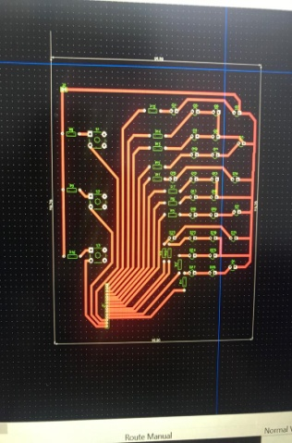 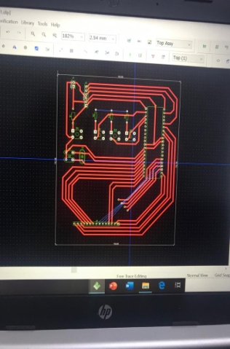 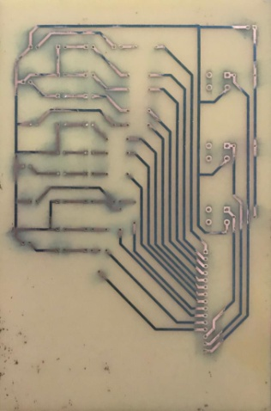

1. ارفاق صفحات مهمة من Data sheet للعناصر